**Weather Trends Project**

**Outlines:**

* SQL command used to extract city level and global temperature data: (Riyadh city chosen for measure up local temperature data)
  + SQl Query Used:

Select

city_data.year,

city_data.avg_temp As Riyadh_avg_temp,

global_data.avg_temp As global_avg_temp

From city_data

Inner join global_data

On global_data.year = city_data.year

Where city_data.city = 'Riyadh'

* MS Excel used to visuals local and global temperature data and calculate moving average, which has been calculated in a spreadsheet using Average Function
* Data sample chosen between years 1900 and 2010.
* Moving average calculated among 10 years.

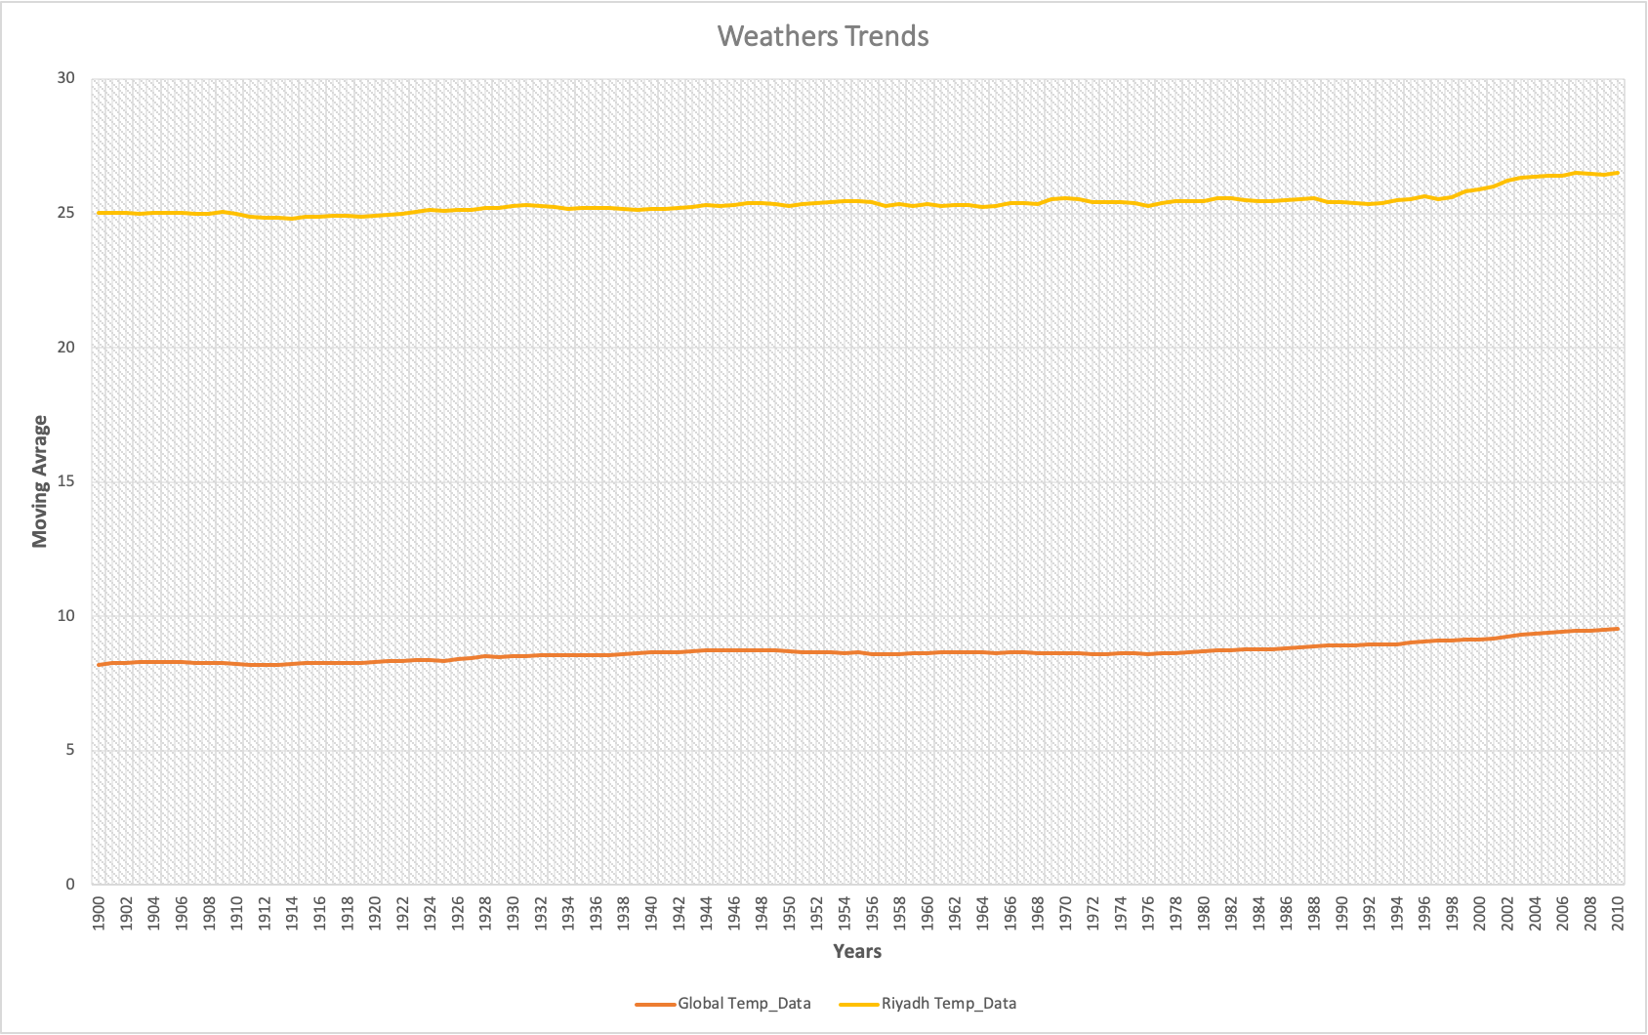

**Analysis**:

As we can see from the above chart, the climate of Riyadh city considered as a hot and dry desert climate where the moving average of temperatures during every 100 years between 25 and 25.8. Whereas the global temperature on the contrary, the climate is to cold and the temperature average between 8 and 8.8. Despite that, this differences of temperatures amongst Riyadh city and global world has been consistent over 100 years ago. Nonetheless, at the last 10 years, started from 2000 G, the moving average for all has been increased whereas turn out to be for Riyadh city between 25.9 and 26.5 and for global world between 9.1 and 9.5. Which makes us to expect the moving average for next 10 years to be increased 0.5 degree for all global worlds and Riyadh city, Consequently, the climate for Riyadh city will be hotter than past 100 years and global worlds will be warm in the future.